CRM DB analysis

Pernebayev Sanzhar

Shuishbaev Nuruddin

Astana IT University

CS-2009

Object-oriented programming Java

Dostiyarov Adilbek

Astana, 2021

**Introduction**

**Background of project:**

Our project was designed to analyze customer relationship management data. We took the client database and enter it into PGadmin and output the data using a java virtual machine. In the project, we used several classes, methods to get the analyzed data.

**Aim of the project:**

1. Entering data into the Pgadmin database using a java virtual machine.
2. Output the analyzed data from the Pgadmin database using a Java virtual machine.

**Our roles in the project:**

Pernebaev Sanzhar - support for the creation of the project architecture, creation of the main diagram, filling in data in the database, partial creation of methods for outputting data in a JVM, testing the project.

Shuishbaev Nuruddin - partial creation of the project architecture, support for the creation analyzed methods in the JVM, filling in data in the database, testing the project.

**ER Diagram**

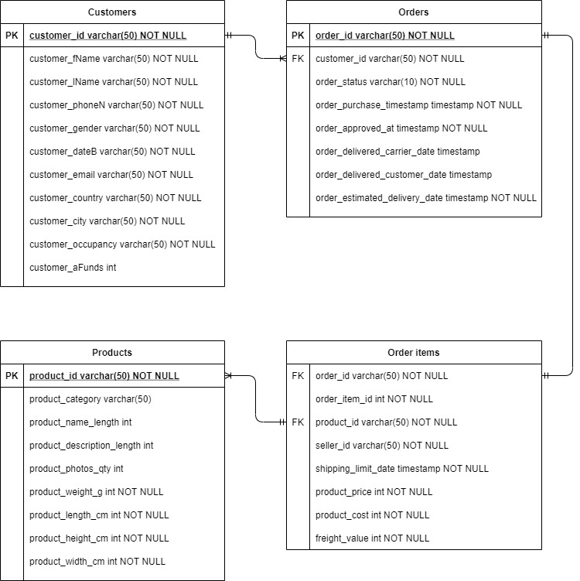

**Description of classes:**

*Class Main*

*Class MyApplication*

Store different objects and refer to other classes.

Methods: start();

*Class Customer*

Store customer related fields (name, gender, etc.) includes several methods.

Methods: Customer_loop(), showAllDataCustomer(), selectTopAgeGroup(), Geolocation(), determineOccupancy();

*CustomerInput*

Extends the Customer class, provides data entry, consists of one method InputData().

*Class Product*

Includes fields related to products (category, number of photos, weight), there are methods ItemLoop(), letterOfNameDescrip(),massOfProduct();

*Class Orders*

Stores order information, includes methods: OrderLoop(), findActiveCustomers(), showOrderStatus();

*Class Order_items*

Storing more detailed order information consists of two methods.

Methods: OrderItemLoop(), calculateProfitOfCompany();

<https://github.com/Sanzhar357/CRM-project>